Mixed Reality Toolkit

General Knowledge:

https://docs.microsoft.com/en-us/windows/mixed-reality/mrtk-unity/?view=mrtkunity-2021-05

Set-Up Tutorial:

<https://docs.microsoft.com/en-us/learn/modules/learn-mrtk-tutorials/1-1-introduction>

Keywords: Single Pass Instanced, Depth Buffer Sharing, 16-bit Depth for optimized performance

Download Mixed Reality Feature Tool:

Select Unity Project -> Platform Support -> Mixed Reality OpenXR plugin

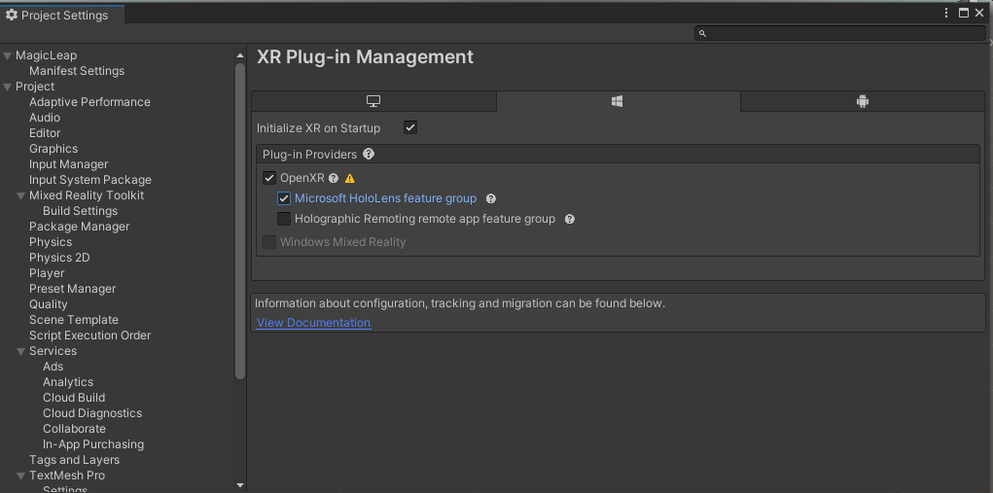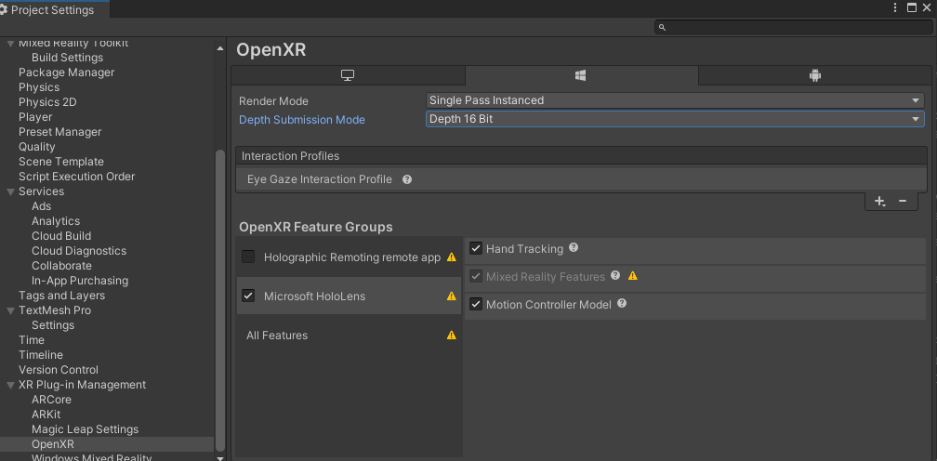

Hololens 1st gen: <https://docs.microsoft.com/en-us/windows/mixed-reality/develop/unity/tutorials/holograms-100>

Αν λείπει κάτι από το Visual Studio κάνε το install.

Window -> Analysis -> Input Debugger -> Options -> Lock Input to game view

Unity Versions : <https://docs.microsoft.com/en-us/windows/mixed-reality/develop/unity/choosing-unity-version>

Αναγκαστικά σε 2019.4.3 LTS, με Legacy XR για Hololens 1. Από 2020 και μετά έχει αφαιρεθεί το Legacy XR και χρησιμοποιείται το OpenXR, αλλά δεν υποστηρίζει Hololens 1 (έτσι λέει τουλάχιστον).

<https://docs.microsoft.com/en-us/learn/modules/learn-mrtk-tutorials/1-5-exercise-configure-resources?tabs=wsa#tabpanel_1_wsa>

MRK 2.7.0

Use Text Mesh Pro Shaders for Mixed Reality Toolkit (Shaders that use Stereo Rendering Method - set to Single Pass Instanced)

Χρειαζόμαστε socket API που να δουλεύει σε UWP:

<https://github.com/endel/NativeWebSocket>

Enable privateNetworkClientServer capability in Package.appxmanifest

**internetClientServer**

<Capability Name ="privateNetworkClientServer" />

<https://docs.microsoft.com/en-us/windows/uwp/packaging/app-capability-declarations>

Graddle Update For AR Core (not using it): <https://developers.google.com/ar/develop/unity/android-11-build>

Sensor Discussion in Unity:

<https://forum.unity.com/threads/unity-and-the-accelerometer-vs-the-gyroscope-a-complete-guide.451496/>